1)1. Setup a virtual machine using Ubuntu image.
2. Install docker on ec2.
3. Pull 5 docker images. (nginx, Apache tomcat, ubuntu, Jenkins, SonarQube)
4. Run nginx container and expose on port 81.
5. Delete the Apache tomcat image from local.
6. Inspect the Jenkins image, SonarQube image.
7. Run Jenkins container and run one sample job.

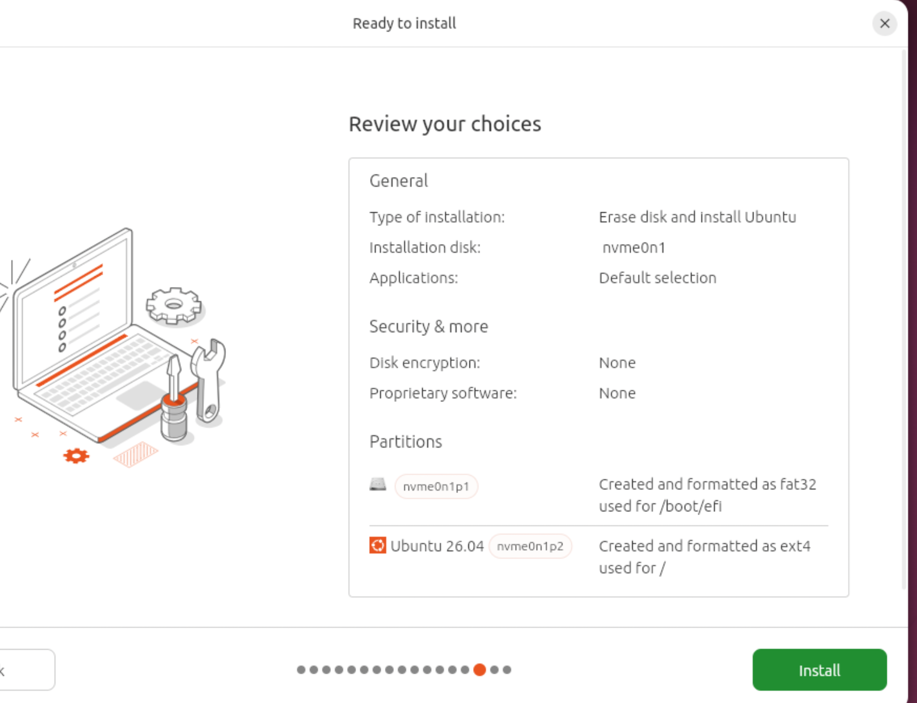

2)
Run one Ec2 instance with large instance
install docker
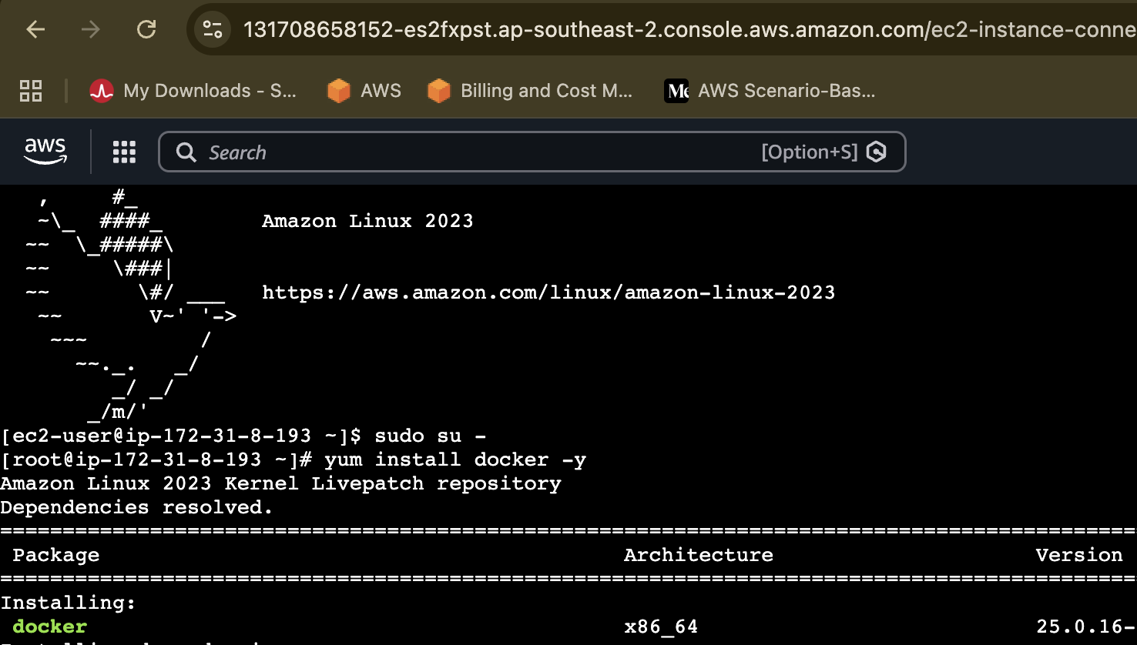
Systemctl start docker

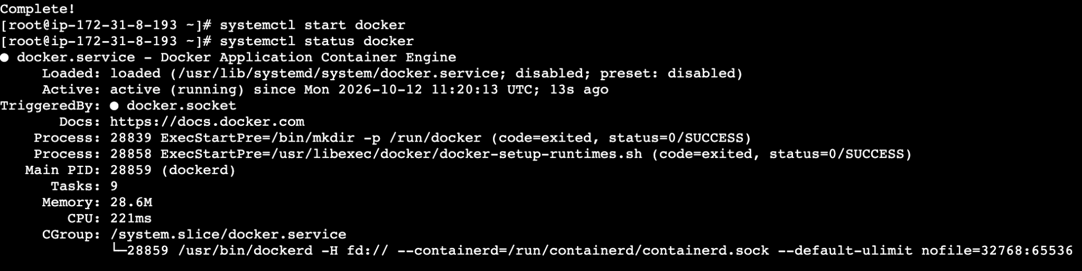

Change the port number from 8080 to 81
“docker run -itd -p 81:80 nginx” → public ip:81 Add security gInbound rules “81”
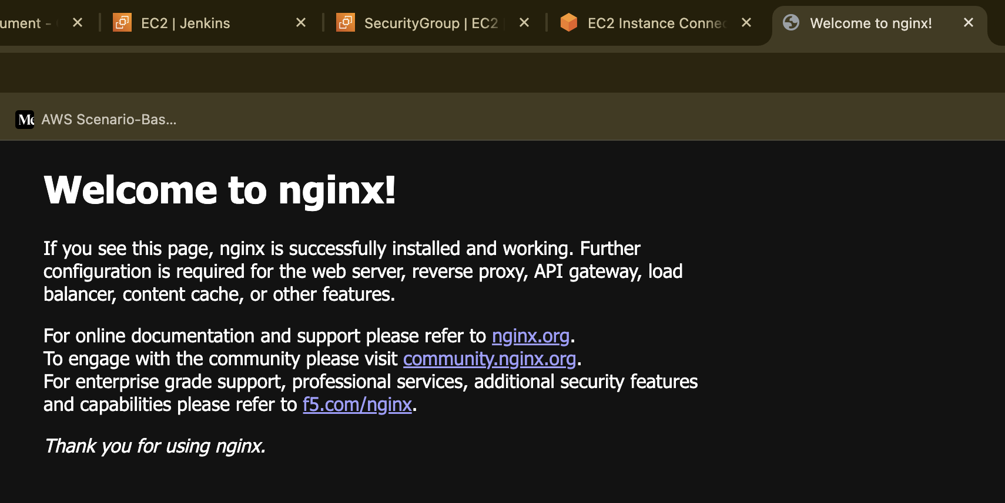

3)
jenkins:2.60.3
tomcat
All images
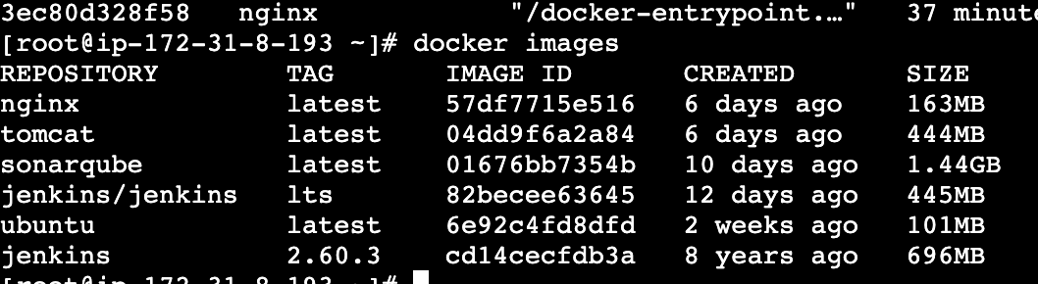

4)docker rmi tomcat → to remove any image

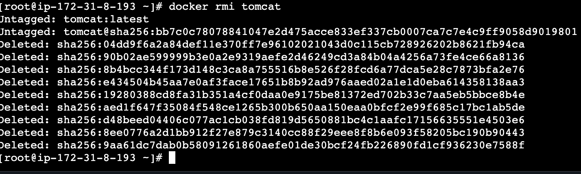

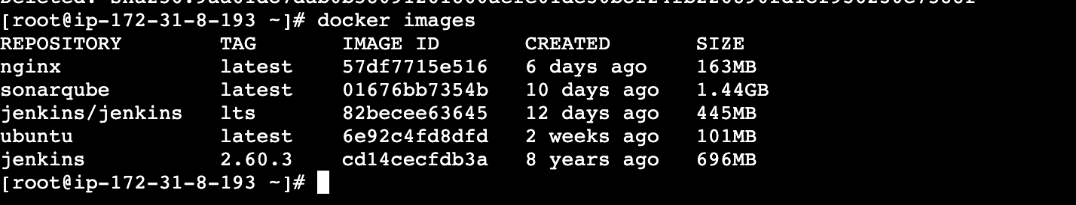
Run docker log jenkins/id for password
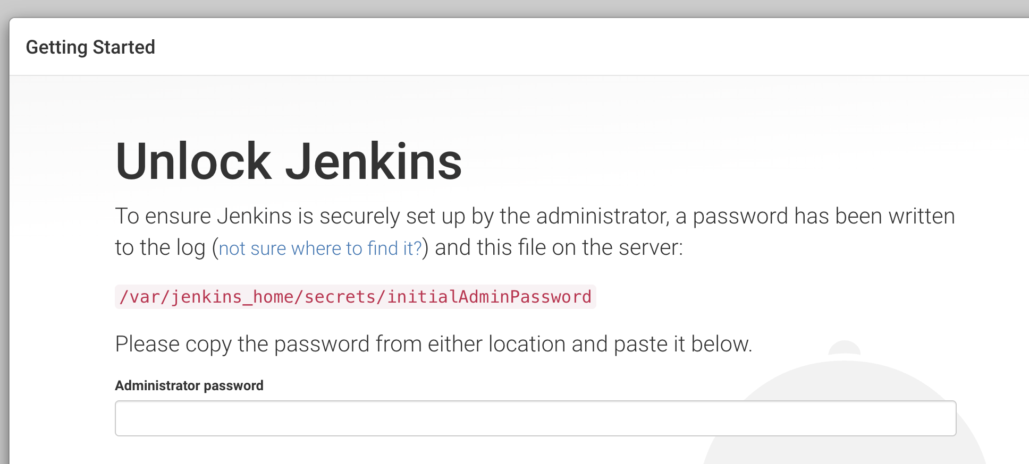

Download image
Convert image to container
Docker run -itd -p 9000 sonarqube

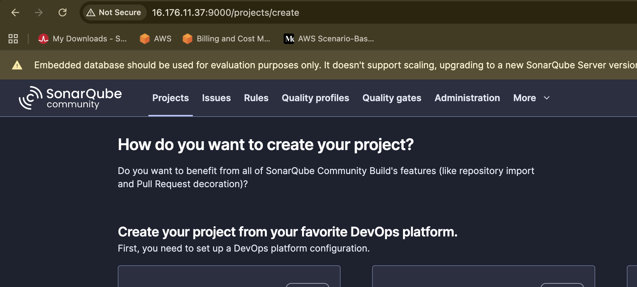
Run a simple job

